**Ejercicios cuaderno PL/SQL**

**Ciclo 2:**

SELECT * FROM ClientePLSQL;

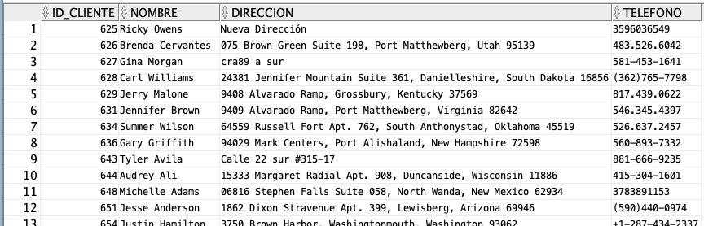

SELECT * FROM AutoPLSQL;

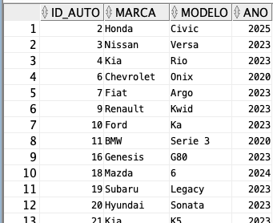

SELECT * FROM AlquilerPLSQL;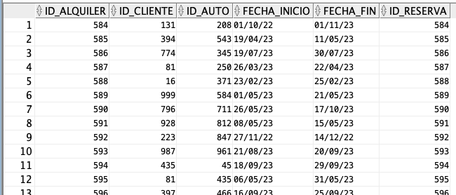

SELECT c.nombre, a.marca, a.modelo FROM ClientePLSQL c

JOIN AlquilerPLSQL al ON c.id_cliente = al.id_cliente

JOIN AutoPLSQL a ON al.id_auto = a.id_auto;

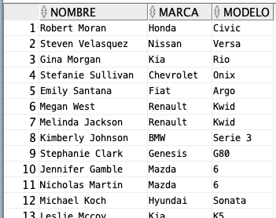

SELECT a.marca, a.modelo, a.ano FROM AutoPLSQL a JOIN AlquilerPLSQL al ON a.id_auto = al.id_auto;

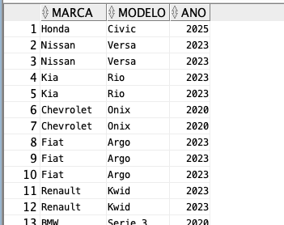

SELECT * FROM AlquilerPLSQL WHERE id_cliente = 1;

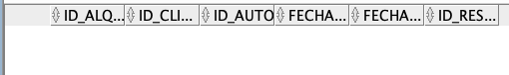

SELECT * FROM AlquilerPLSQL WHERE id_auto = 1;



SELECT * FROM AlquilerPLSQL WHERE id_sucursal = 1;

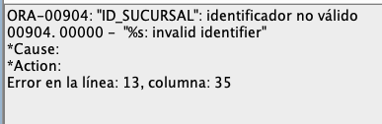

SELECT * FROM AlquilerPLSQL WHERE fecha_inicio = '27/09/23';

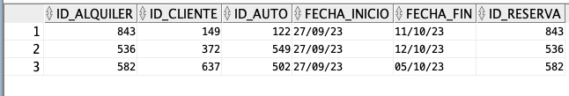

SELECT COUNT(*) FROM AlquilerPLSQL;



SELECT

c.nombre

FROM

ClientePLSQL c

JOIN

AlquilerPLSQL a ON c.id_cliente = a.id_cliente

JOIN

ReservaPLSQL r ON a.id_reserva = r.id_reserva

JOIN

SucursalPLSQL s ON r.id_sucursal = s.id_sucursal

WHERE

s.nombre = 'Sucursal Central';



SELECT a.marca, a.modelo

FROM AutoPLSQL a

JOIN AlquilerPLSQL al ON a.id_auto = al.id_auto

WHERE al.id_cliente = 1 AND al.fecha_inicio = TO_DATE('27/09/2023', 'DD/MM/YYYY');



SELECT * FROM AlquilerPLSQL WHERE fecha_fin - fecha_inicio > 7;

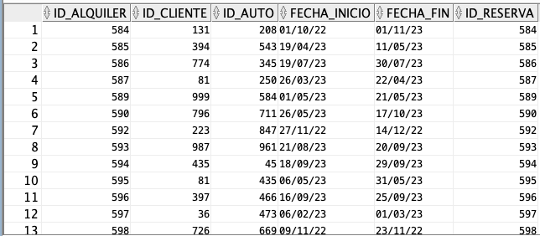

SELECT c.nombre, COUNT(*) AS numero_alquileres

FROM ClientePLSQL c

JOIN AlquilerPLSQL a ON c.id_cliente = a.id_cliente

GROUP BY c.nombre

ORDER BY numero_alquileres DESC

FETCH FIRST 1 ROWS ONLY;



SELECT s.nombre, COUNT(*) AS numero_alquileres

FROM SucursalPLSQL s

JOIN AlquilerPLSQL al ON s.id_sucursal = al.id_sucursal

GROUP BY s.nombre

ORDER BY numero_alquileres DESC

FETCH FIRST 1 ROWS ONLY;

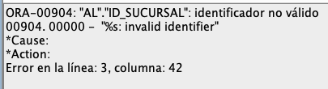

SELECT EXTRACT(MONTH FROM fecha_inicio) AS mes, COUNT(*) AS numero_alquileres

FROM AlquilerPLSQL

GROUP BY EXTRACT(MONTH FROM fecha_inicio)

ORDER BY numero_alquileres DESC

FETCH FIRST 1 ROWS ONLY;



SELECT TO_CHAR(fecha_inicio, 'D') AS dia_semana, COUNT(*) AS numero_alquileres

FROM AlquilerPLSQL

GROUP BY TO_CHAR(fecha_inicio, 'D')

ORDER BY numero_alquileres DESC

FETCH FIRST 1 ROWS ONLY;



SELECT * FROM AlquilerPLSQL ORDER BY precio DESC FETCH FIRST 1 ROWS ONLY;

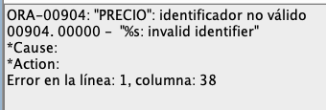

SELECT * FROM AlquilerPLSQL ORDER BY precio ASC FETCH FIRST 1 ROWS ONLY;

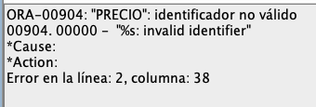

SELECT * FROM ClientePLSQL WHERE nombre LIKE '%Juan%';

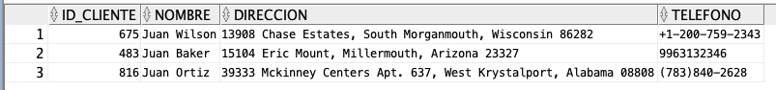

SELECT a.marca, a.modelo, a.ano FROM AutoPLSQL a WHERE precio < 10000;

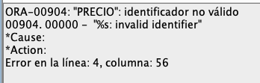

SELECT * FROM AlquilerPLSQL WHERE fecha_inicio BETWEEN TO_DATE('2023-09-01', 'YYYY-MM-DD') AND TO_DATE('2023-09-30', 'YYYY-MM-DD');

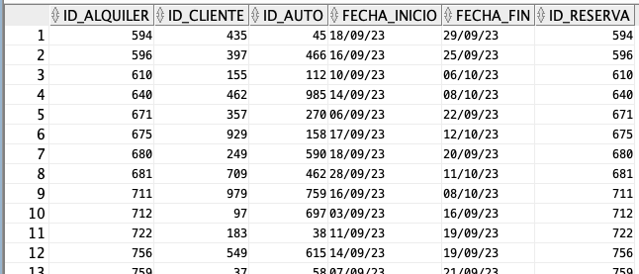

SELECT c.nombre, a.marca, a.modelo FROM ClientePLSQL c JOIN AlquilerPLSQL a ON c.id_cliente = a.id_cliente WHERE c.direccion LIKE '%Bogotá%';

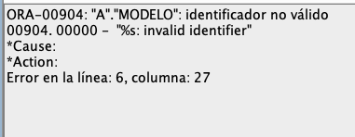

SELECT a.marca, a.modelo, a.ano FROM AutoPLSQL a JOIN AlquilerPLSQL al ON a.id_auto = al.id_auto WHERE al.id_reserva = 1;



SELECT * FROM AlquilerPLSQL WHERE id_cliente IN (1, 2, 3);

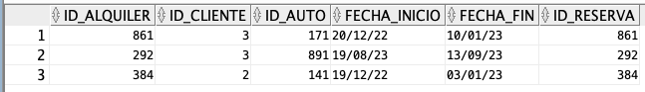

SELECT * FROM AlquilerPLSQL WHERE id_auto IN (1, 2, 3);

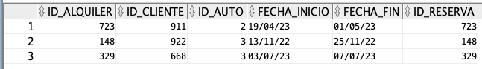

SELECT * FROM AlquilerPLSQL WHERE id_sucursal IN (1, 2, 3);

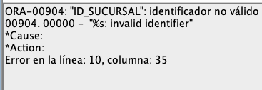

SELECT * FROM AlquilerPLSQL WHERE fecha_inicio BETWEEN TO_DATE('2023-09-01', 'YYYY-MM-DD') AND TO_DATE('2023-09-30', 'YYYY-MM-DD') AND id_cliente IN (1, 2, 3);



SELECT * FROM AlquilerPLSQL WHERE fecha_inicio BETWEEN TO_DATE('2023-09-01', 'YYYY-MM-DD') AND TO_DATE('2023-09-30', 'YYYY-MM-DD') AND id_auto IN (1, 2, 3);



SELECT * FROM AlquilerPLSQL WHERE fecha_inicio BETWEEN TO_DATE('2023-09-01', 'YYYY-MM-DD') AND TO_DATE('2023-09-30', 'YYYY-MM-DD') AND id_sucursal IN (1, 2, 3);

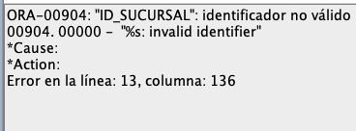

SELECT c.nombre, COUNT(*) AS numero_alquileres FROM ClientePLSQL c JOIN AlquilerPLSQL a ON c.id_cliente = a.id_cliente GROUP BY c.nombre ORDER BY numero_alquileres DESC FETCH FIRST 1 ROWS ONLY;



SELECT a.marca, a.modelo, COUNT(*) AS numero_alquileres FROM AutoPLSQL a JOIN AlquilerPLSQL al ON a.id_auto = al.id_auto GROUP BY a.marca, a.modelo ORDER BY numero_alquileres DESC FETCH FIRST 1 ROWS ONLY;



SELECT EXTRACT(MONTH FROM fecha_inicio) AS mes, COUNT(*) AS numero_alquileres FROM AlquilerPLSQL GROUP BY EXTRACT(MONTH FROM fecha_inicio) ORDER BY numero_alquileres DESC FETCH FIRST 1 ROWS ONLY;



SELECT TO_CHAR(fecha_inicio, 'D') AS dia_semana, COUNT(*) AS numero_alquileres FROM AlquilerPLSQL GROUP BY TO_CHAR(fecha_inicio, 'D') ORDER BY numero_alquileres DESC FETCH FIRST 1 ROWS ONLY;



SELECT * FROM ClientePLSQL WHERE nombre LIKE '%Juan%' AND fecha_inicio BETWEEN TO_DATE('2023-09-01', 'YYYY-MM-DD') AND TO_DATE('2023-09-30', 'YYYY-MM-DD');

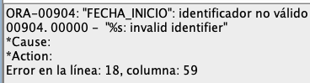

SELECT a.marca, a.modelo, a.ano FROM AutoPLSQL a WHERE precio < 10000 AND fecha_inicio BETWEEN TO_DATE('2023-09-01', 'YYYY-MM-DD') AND TO_DATE('2023-09-30', 'YYYY-MM-DD');

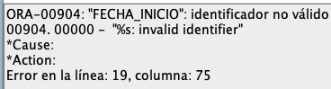

SELECT * FROM AlquilerPLSQL ORDER BY precio DESC LIMIT 1;

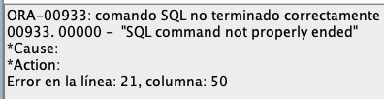

SELECT * FROM AlquilerPLSQL ORDER BY precio ASC LIMIT 1;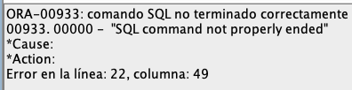

SELECT * FROM ClientePLSQL WHERE nombre LIKE '%Juan%' AND fecha_inicio BETWEEN '2023-09-01' AND '2023-09-30'; SELECT a.marca, a.modelo, a.ano FROM AutoPLSQL a WHERE precio < 10000 AND fecha_inicio BETWEEN '2023-09-01' AND '2023-09-30';

